<!DOCTYPE html>
<html lang="en">
<head>
<meta charset="UTF-8">
<meta name="viewport" content="width=device-width, initial-scale=1.0">
<title>My Portfolio[Angel Biju]</title>
</head>
<body>
<nav>
<a href="#about">About</a>
<a href="#skills">Abilities</a>
<a href="#projects">Projects</a>
<a href="#contact">Contact</a>
</nav>
<header>
<h1>Hi I'm Angel Biju😊👀</h1>
<p>I'm a passionate web developer based in Mysuru. Also a novice to cybersecurity.</p>
<a href="#hire">Hire me</a>
</header>

<section id="about">
<h2>About me</h2>
<img src="Profile.png" alt="Profile Picture" width="50px" height="50px">
<p>I love building programs, moreover using my analytical skills to find better and simpler ways to connect elements</p>
</section>

<section id="skills">
<h2>My Skills</h2>
<table border="5px solid">
<tr>
<td>Technology</td>
<td>Proficiency</td>
<td>Years of Experience</td>
</tr><tr>
<td>HTML</td>
<td>Intemediate</td>
<td>5</td>
</tr><tr>
<td>PYTHON</td>
<td>Intermediate</td>
<td>1</td>
</tr><tr>
<td>C</td>
<td>Intermediate</td>
<td>1</td>
</tr><tr>
<td>CSS</td>
<td>Novice</td>
<td>0.1</td>
</tr>
<tr>
<td>JAVASCRIPT</td>
<td>Novice</td>
<td>0.1</td>
</tr>
</table>
</section>

<section id="projects">
<h2>My Project</h2>
<h4>Project 1</h4>
<p>Description of project 1
<a href="#view project">View Project</a></p>

<h4>Project 2</h4>
<p>Description of project 2
<a href="#view project">View Project</a></p>

<h4>Project 3</h4>
<p>Description of project 3
<a href="#view project">View Project</a></p>
</section>

<section id="contact">
<h2>Contact Me</h2>
<p>Email:<a href="mailto:angelbiju2327@gmail.com">angelbiju2327@gmail.com</a></p>
<p>Github: <a href="https://github.com/anglemichael">anglemichael</a></p>
<p>Linkedin: <a href="https://linkedin.com/in/angel-biju-aa17b8386">Angel Biju</a></p>
</section>
<section id="hire">
<h2>Hire Me</h2>
<p>Have a project in mind? Let’s talk!</p>
<form action="">
<label for="name">Your name</label>
<input type="text" name="name" id="name" placeholder="Enter your name" required><br>
<label for="mail">Your email</label>
<input type="email" name="mail" id="mail" placeholder="Enter your email" required><br>
<label for="subject">Subject</label>
<select name="subject" id="subject">
<option value="--select a value--">--Select an option--</option>
<option value="hire">I want to hire you</option>
<option value="collab">I want to collaborate</option>
<option value="other">Other</option><br>
</select><br>
<label for="msg">Message</label>
<textarea name="msg" id="msg" placeholder="Feedback/Message"></textarea><br>
<button type="submit">Send Message📤</button>

</form>
</section>

<footer>
<p>© 2026[ANGEL BIJU]. All Rights Reserved. </p>
</footer>
</body>
</html>

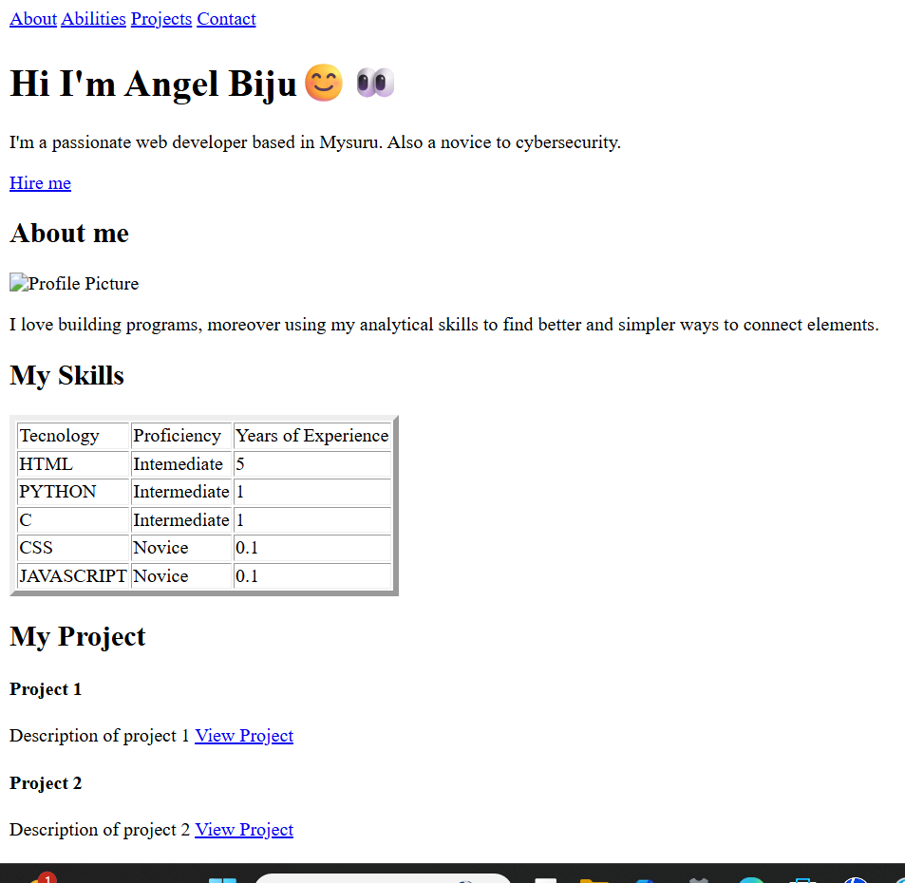
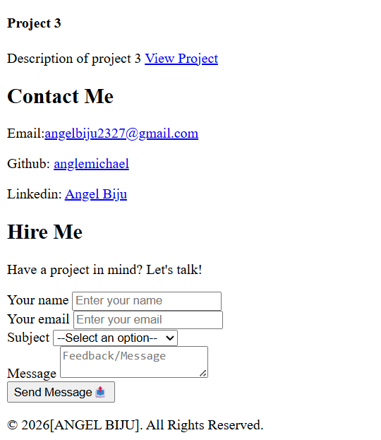

<!DOCTYPE html>
<html lang="en">
<head>
<meta charset="UTF-8">
<meta name="viewport" content="width=device-width, initial-scale=1.0">
<title>Document</title>
</head>
<body>
<form action="">
<label for="fullname">Name:</label><br>
<input type="text" placeholder="Enter your name" id="fullname" name="fullname" required> <br>

<!--Email-->
<label for="email">Email Address:</label><br>
<input type="email" placeholder="Enter valid mail ID" name="email" id="email" required> <br>

<!-- Password-->
<label for="psw">Password:</label> <br>
<input type="password" placeholder="Enter Password" minlength="8" maxlength="15" name="psw" id="psw" required><br>

<!-- number input -->
<label for="age">Age:</label><br>
<input type="number" placeholder="Enter age" id="age" name="age" min="18" max="100"> <br>

<!-- radio button -->
<p>Gender:</p>
<input type="radio" id="female" name="gender" value="female">
<label for="gender">Female</label> <br>
<input type="radio" id="male" name="gender" value="male">
<label for="gender">Male</label> <br>
<input type="radio" id="notsay" name="gender" value="notsay">
<label for="gender">Rather Not Say</label> <br>

<!-- checkbox -->
<p>Skills:</p>
<input type="checkbox" name="html" id="html" value="html">
<label for="html">HTML</label><br>
<input type="checkbox" name="css" id="css" value="css">
<label for="css">CSS</label><br>

<!-- dropdown -->
<label for="country">Country</label>
<select name="country" id="country">
<option value="india">India</option>
<option value="usa">USA</option>
<option value="australia">Australia</option>
</select><br>

<!-- text area -->
<label for="message">Message:</label>
<textarea name="message" id="message" placeholder="Please drop a message"></textarea><br>

<!-- file upload -->
<label for="resume">Upload Resume:</label>
<input type="file" name="resume" id="resume"><br>

<!-- date picker -->
<label for="dob">Date of Birth: </label>
<input type="date" name="dob" id="dob"><br><br>

<!--Button-->
<button type="submit">Submit</button>
<button type="reset">Reset</button>
</form>
</body>
</html>

